U3A Christchurch Central
Course 6 – Innovative Companies
Course Organiser: Sue Allard

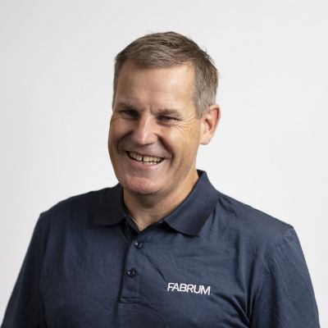 | 8 September, Christopher Boyle, Co-founder and Chair of Fabrum  From Canterbury to the Cosmos: How Cryogenics is Powering Clean Energy and Saving Lives  Discover how Fabrum is helping shape the future of clean energy through world-leading innovation in cryogenics, composites, and advanced engineering. This presentation explores Fabrum’s purpose, the solutions we deliver, and the real-world impact our technologies are making for customers, industries, and a more sustainable future.
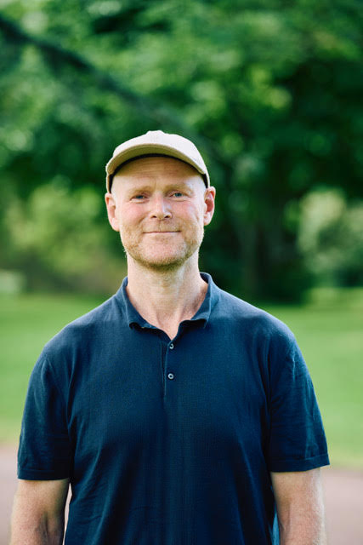 | 15 September, Ben Fahy, Rewiring Aotearoa, Head of Communications  Electrify everything - and everyone  Everyone wins when we go electric. Homes save thousands, communities save millions and the country saves billions, while also improving energy security and reducing emissions. So how do we make the electric boat go faster? And how can you help?
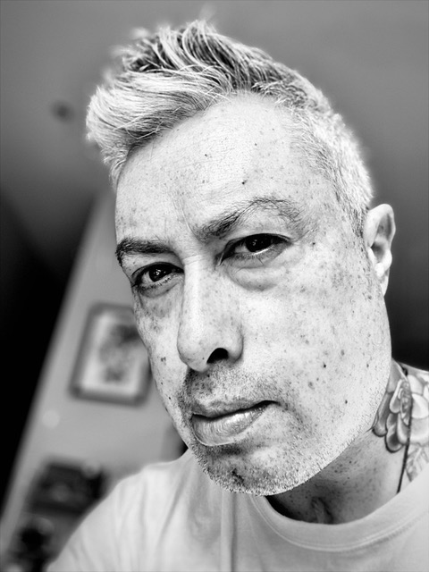 | 22 September, Eric UfiPoa, Swaltech – Patient Engagement Specialist  Patient Driven Innovation  Eric was a firefighter for 12 years until a stroke at 32 forced him to rebuild everything, including his swallow. He now lives with a disability and speaks differently, and he draws on that lived experience in his work in patient‑driven innovation at Swallowing Technologies. His talk explores how lived experience can change the way we create rehab tools that actually work in real life.

